Test Case: tc001_SPX_Dev5_Crear_Solicitud_Articulo_Almacen
Step 1 - Enter username and password and click to button Enter : Credentials Entered
Image file-name: QC_Testing-tc001_SPX_Dev5_Crear_Solicitud_Articulo_Almacen-1787854070445

Step 2 - Select to UEN and Access to Request for a New Inventory Item : UEN Correctly selected and Correct access
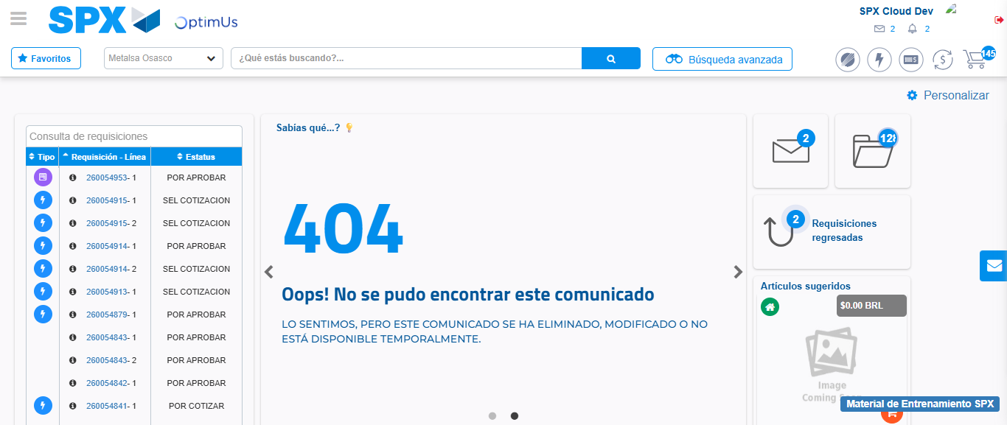Image file-name: QC_Testing-tc001_SPX_Dev5_Crear_Solicitud_Articulo_Almacen-1787854096746

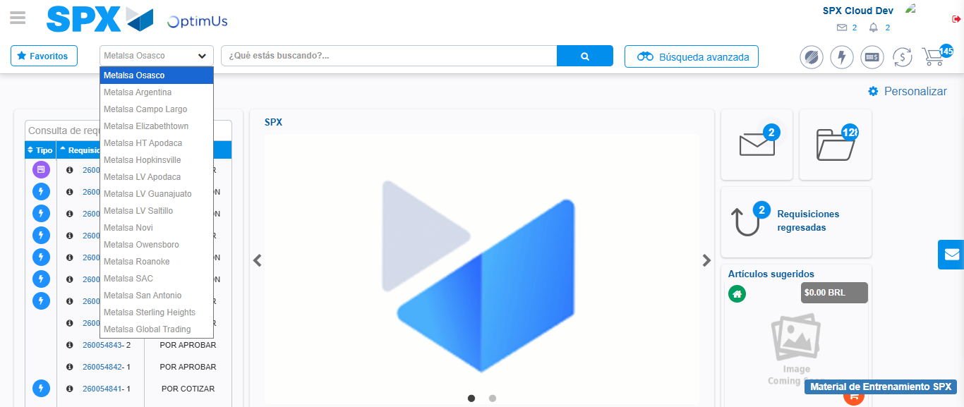Image file-name: QC_Testing-tc001_SPX_Dev5_Crear_Solicitud_Articulo_Almacen-1787854097482

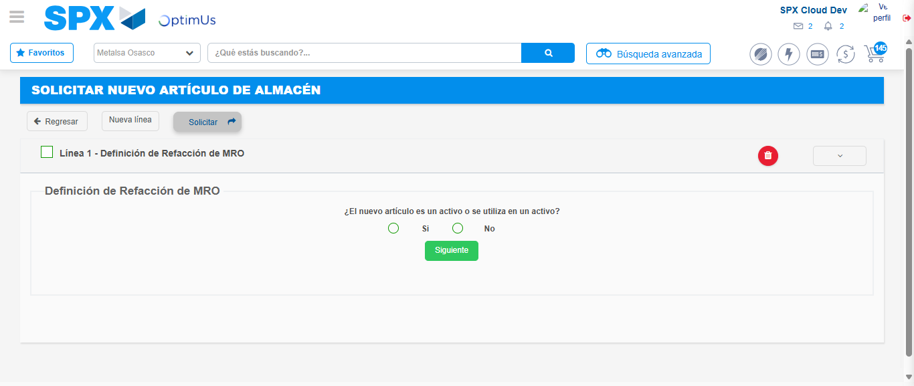Image file-name: QC_Testing-tc001_SPX_Dev5_Crear_Solicitud_Articulo_Almacen-1787854123027

Step 3 - Select options first section : Options seleted correctly
Image file-name: QC_Testing-tc001_SPX_Dev5_Crear_Solicitud_Articulo_Almacen-1787854123334

Image file-name: QC_Testing-tc001_SPX_Dev5_Crear_Solicitud_Articulo_Almacen-1787854123584

Step 7 - Return to Main Page SPX : Return to Main Page SPX
Image file-name: QC_Testing-tc001_SPX_Dev5_Crear_Solicitud_Articulo_Almacen-1787854096746

Image file-name: QC_Testing-tc001_SPX_Dev5_Crear_Solicitud_Articulo_Almacen-1787854097482

Image file-name: QC_Testing-tc001_SPX_Dev5_Crear_Solicitud_Articulo_Almacen-1787854123027

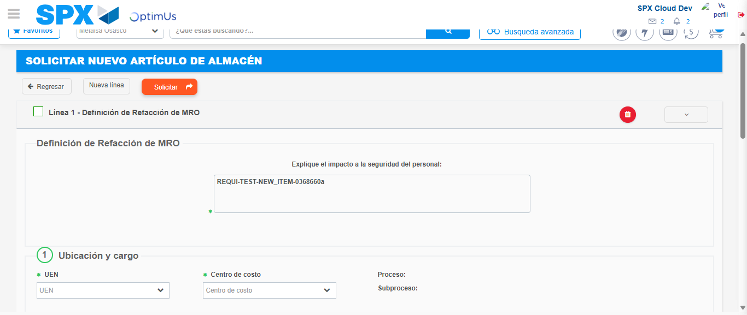Image file-name: QC_Testing-tc001_SPX_Dev5_Crear_Solicitud_Articulo_Almacen-1787854133680

Image file-name: QC_Testing-tc001_SPX_Dev5_Crear_Solicitud_Articulo_Almacen-1787854133912

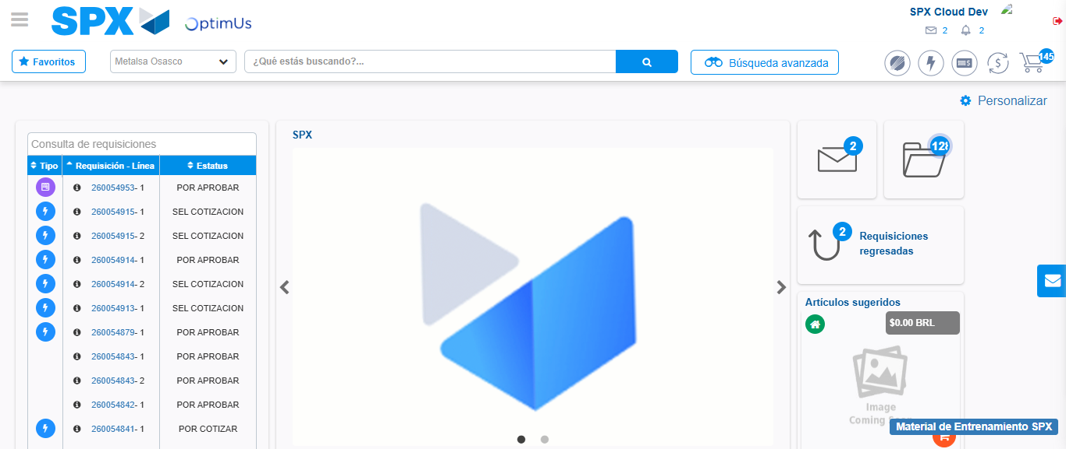Image file-name: QC_Testing-tc001_SPX_Dev5_Crear_Solicitud_Articulo_Almacen-1787854155438

Step 8 - Log Out : Log Out SPX
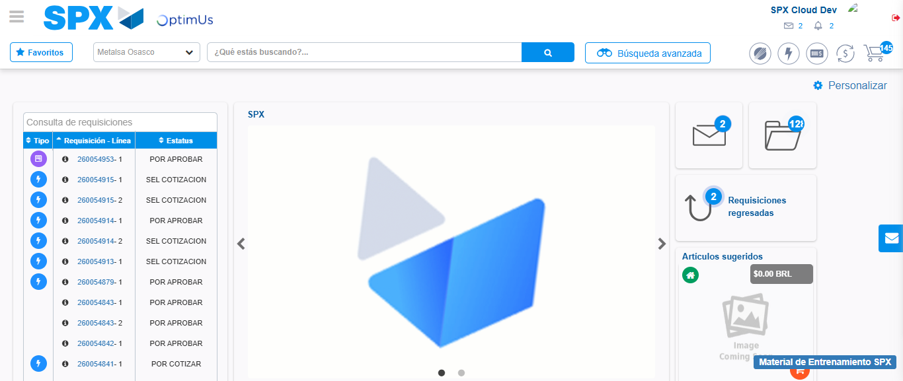Image file-name: QC_Testing-tc001_SPX_Dev5_Crear_Solicitud_Articulo_Almacen-1787854155779

